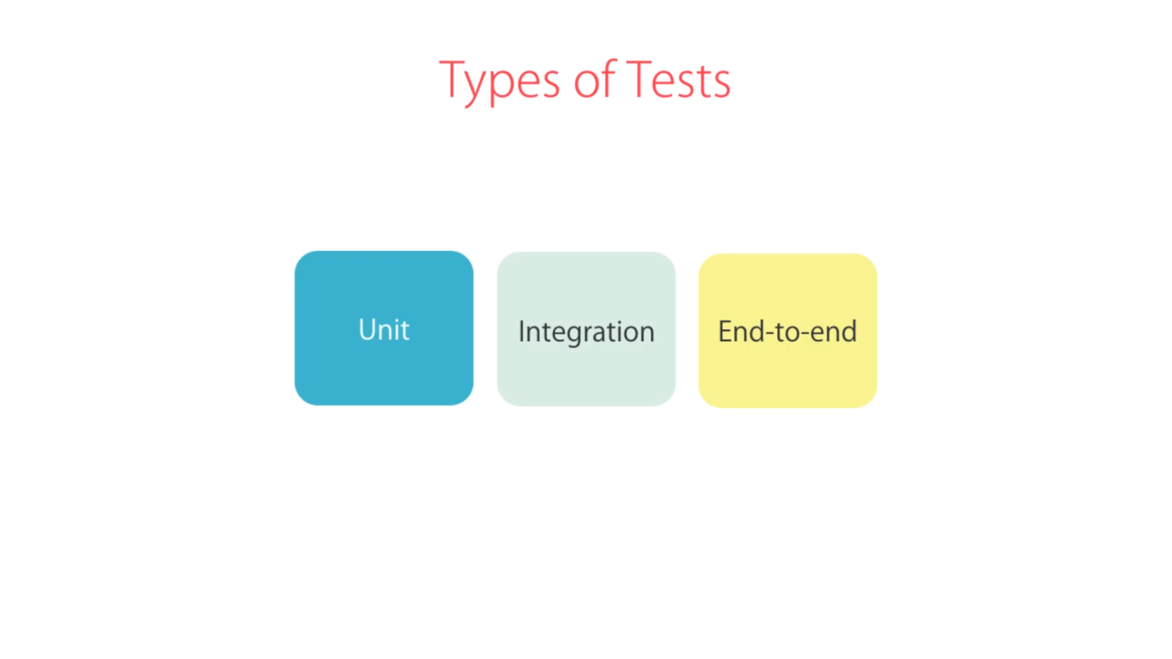

**Unit Test : Component**

Test a component in isolation, without a external resources. (e.g. file system,data base, API endpoints)

* Easy to write
* Super fast
* Don’t give us much confidence

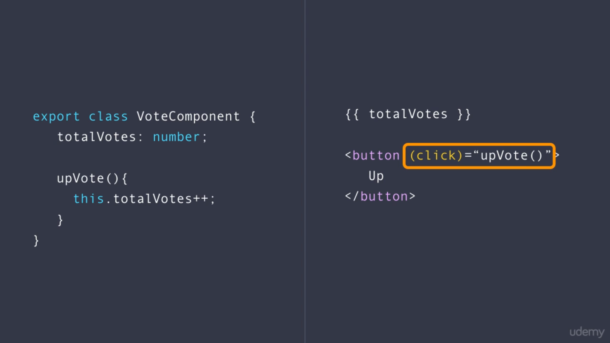

**Integration Test : Component + Template**

Test a component with external resources. (e.g. file system, data base, API endpoints)

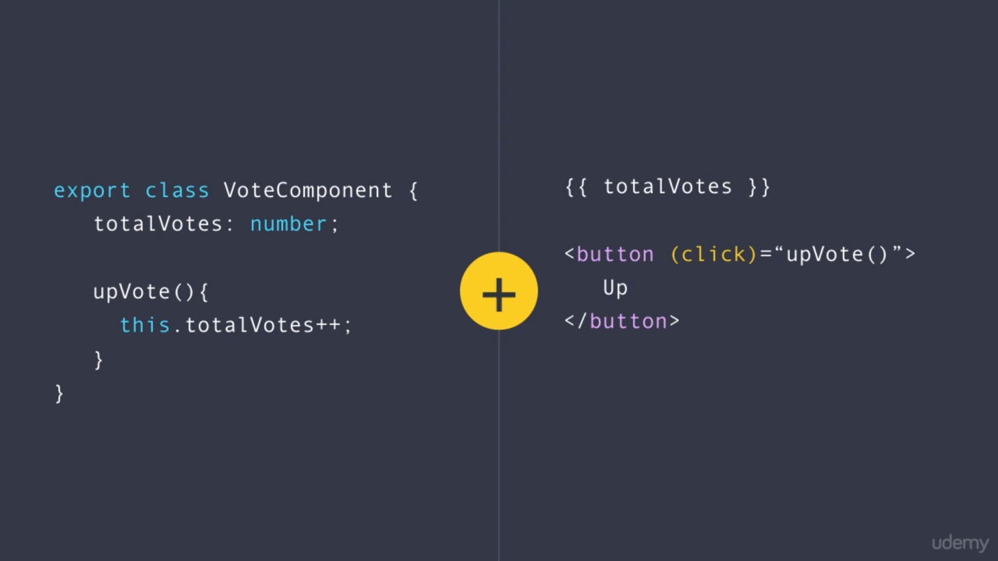

**End-to-end Tests**

Test the entire application as a whole

* More confidence
* Very slow
* Very fragile